Historical Figures Knowledge Base
This document contains facts about notable historical figures, including details about their nationality, lifespan, contributions, and notable achievements. It serves as a knowledge base for the Historical Figures Chatbot.
Cleopatra (69 BCE - 30 BCE)
- Nationality: Egyptian
- Lifespan: 69 BCE - 30 BCE
- Contribution: Last active ruler of the Ptolemaic Kingdom of Egypt
- Trivia: Known for her political alliances with Julius Caesar and Mark Antony. Spoke nine languages, including Egyptian, unlike her predecessors.
Leonardo da Vinci (1452 - 1519)
- Nationality: Italian
- Lifespan: 1452 - 1519
- Contribution: Polymath, artist, and inventor
- Trivia: Painted the Mona Lisa and The Last Supper. His notebooks contain designs for flying machines and anatomical studies far ahead of his time.
Mahatma Gandhi (1869 - 1948)
- Nationality: Indian
- Lifespan: 1869 - 1948
- Contribution: Leader of India's non-violent independence movement
- Trivia: Pioneered satyagraha, a form of non-violent resistance. Led the Salt March in 1930 to protest British salt taxes.
Albert Einstein (1879 - 1955)
- Nationality: German (later Swiss, American)
- Lifespan: 1879 - 1955
- Contribution: Theoretical physicist
- Trivia: Developed the theory of relativity, including E=mc². Won the Nobel Prize in Physics in 1921 for his work on the photoelectric effect.

Working of Chat Bot:
Name : Historical Figure Assistant
Working bot Screen:
First Screen
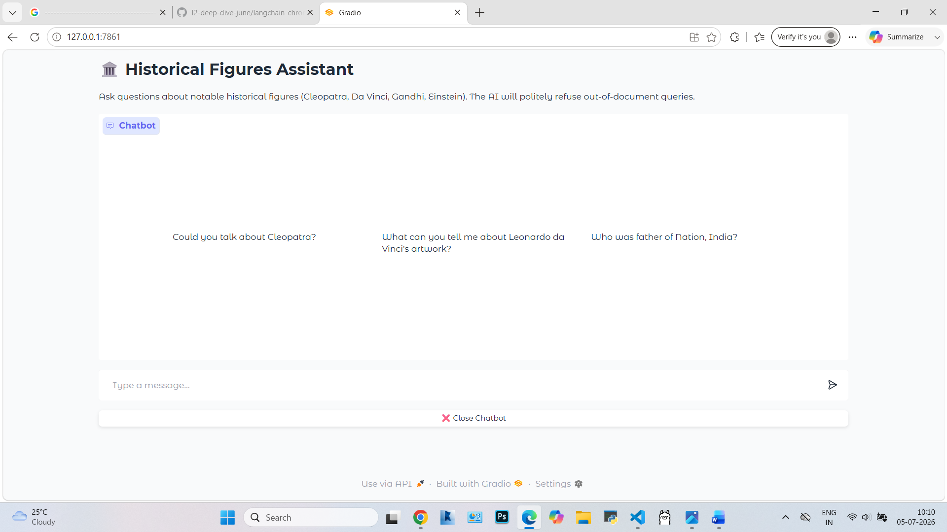
User : Hi
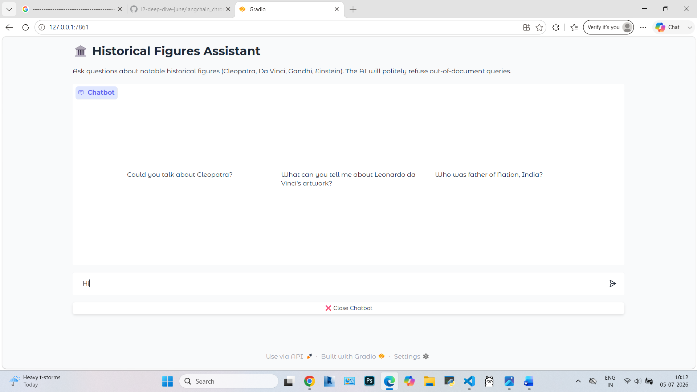
Response
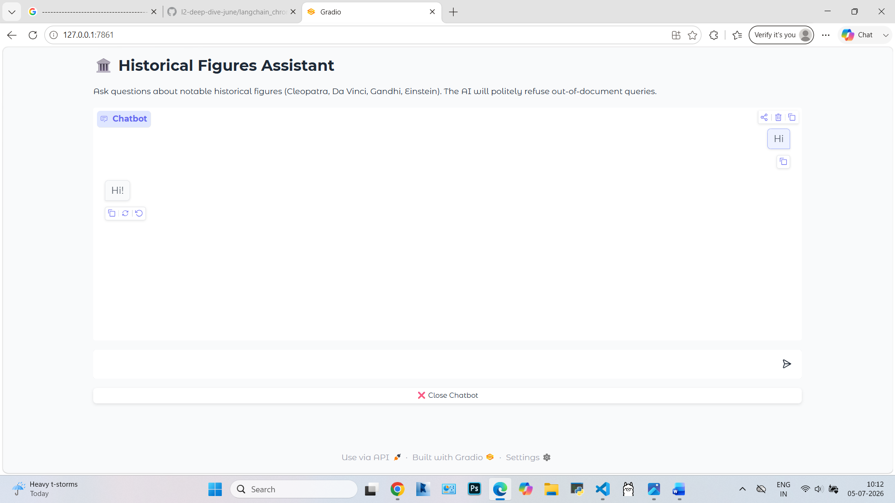

User : Que about Cleopatra
Who was Cleopatra?
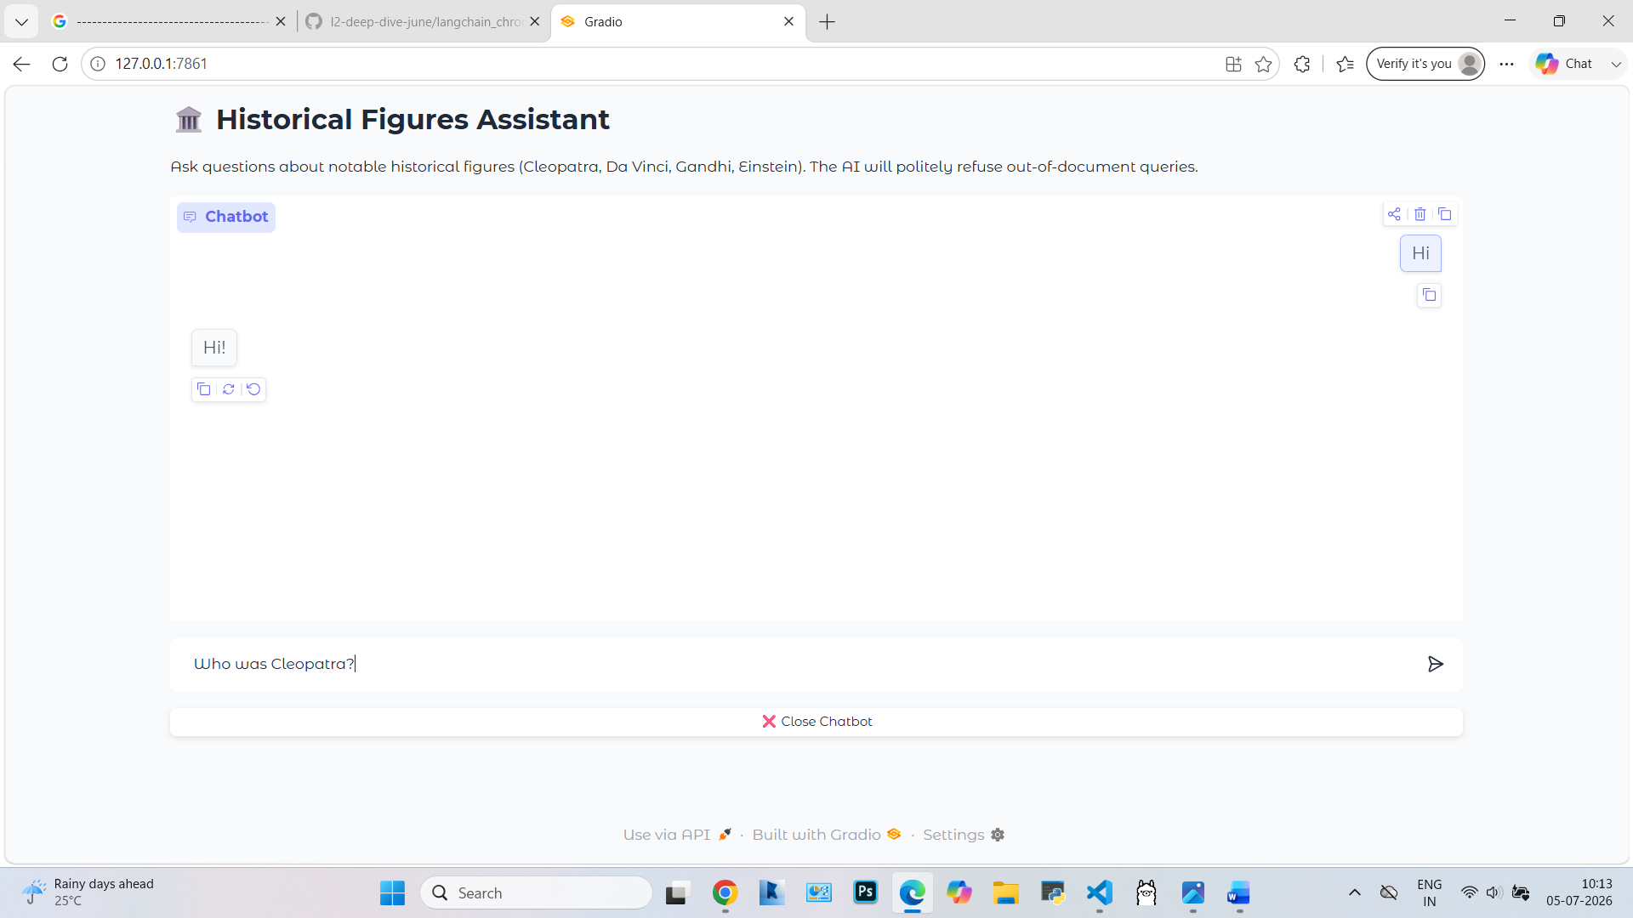
Response
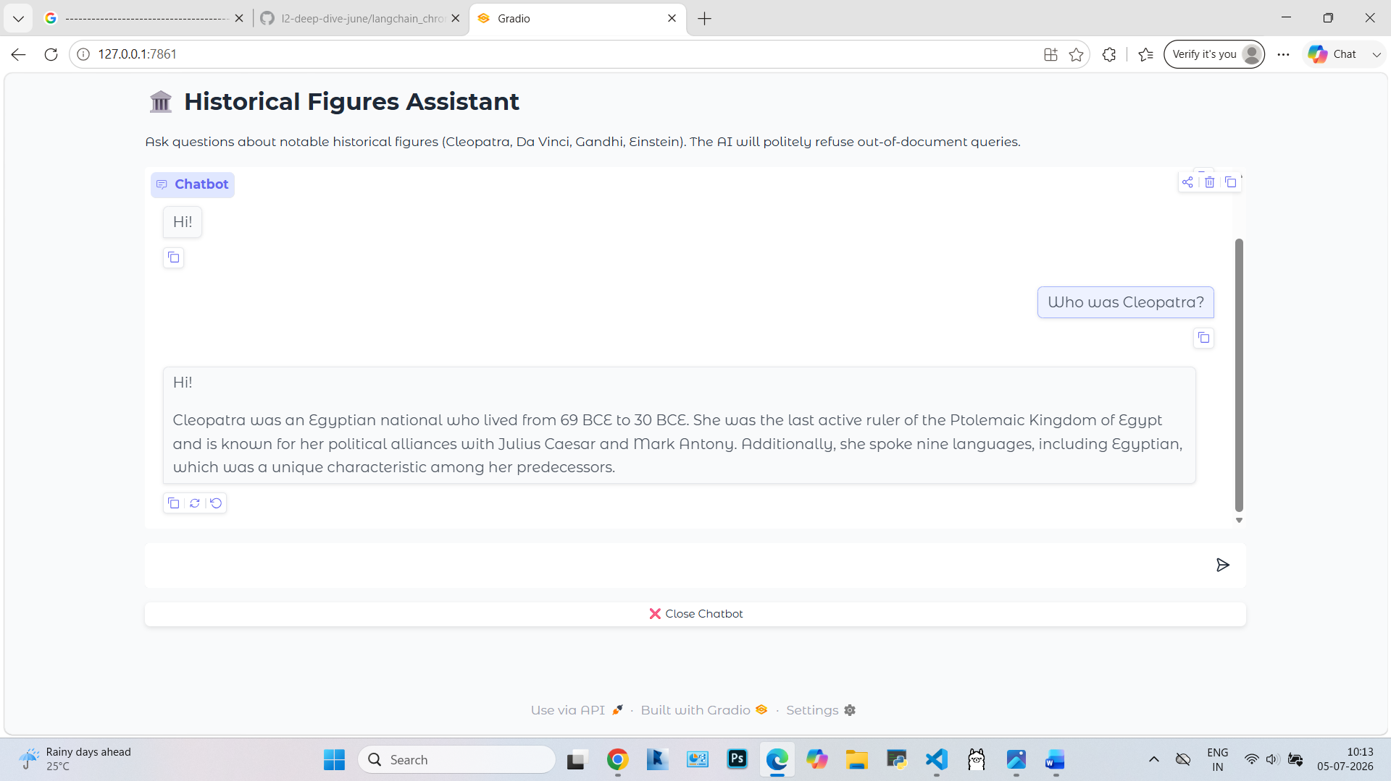

User : Tell me something more about her?
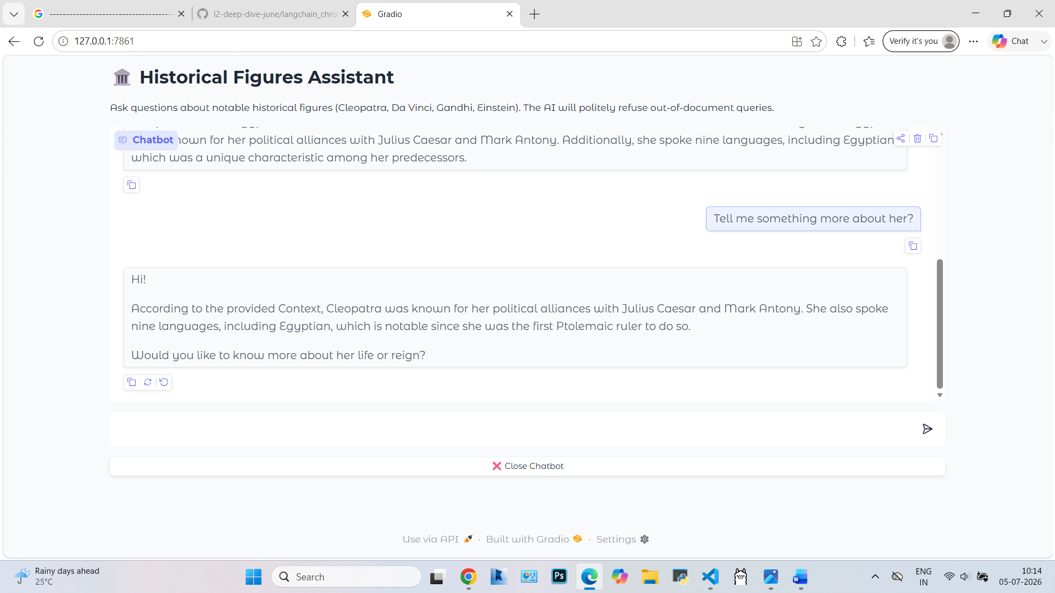

User : what is so special about Einstein?
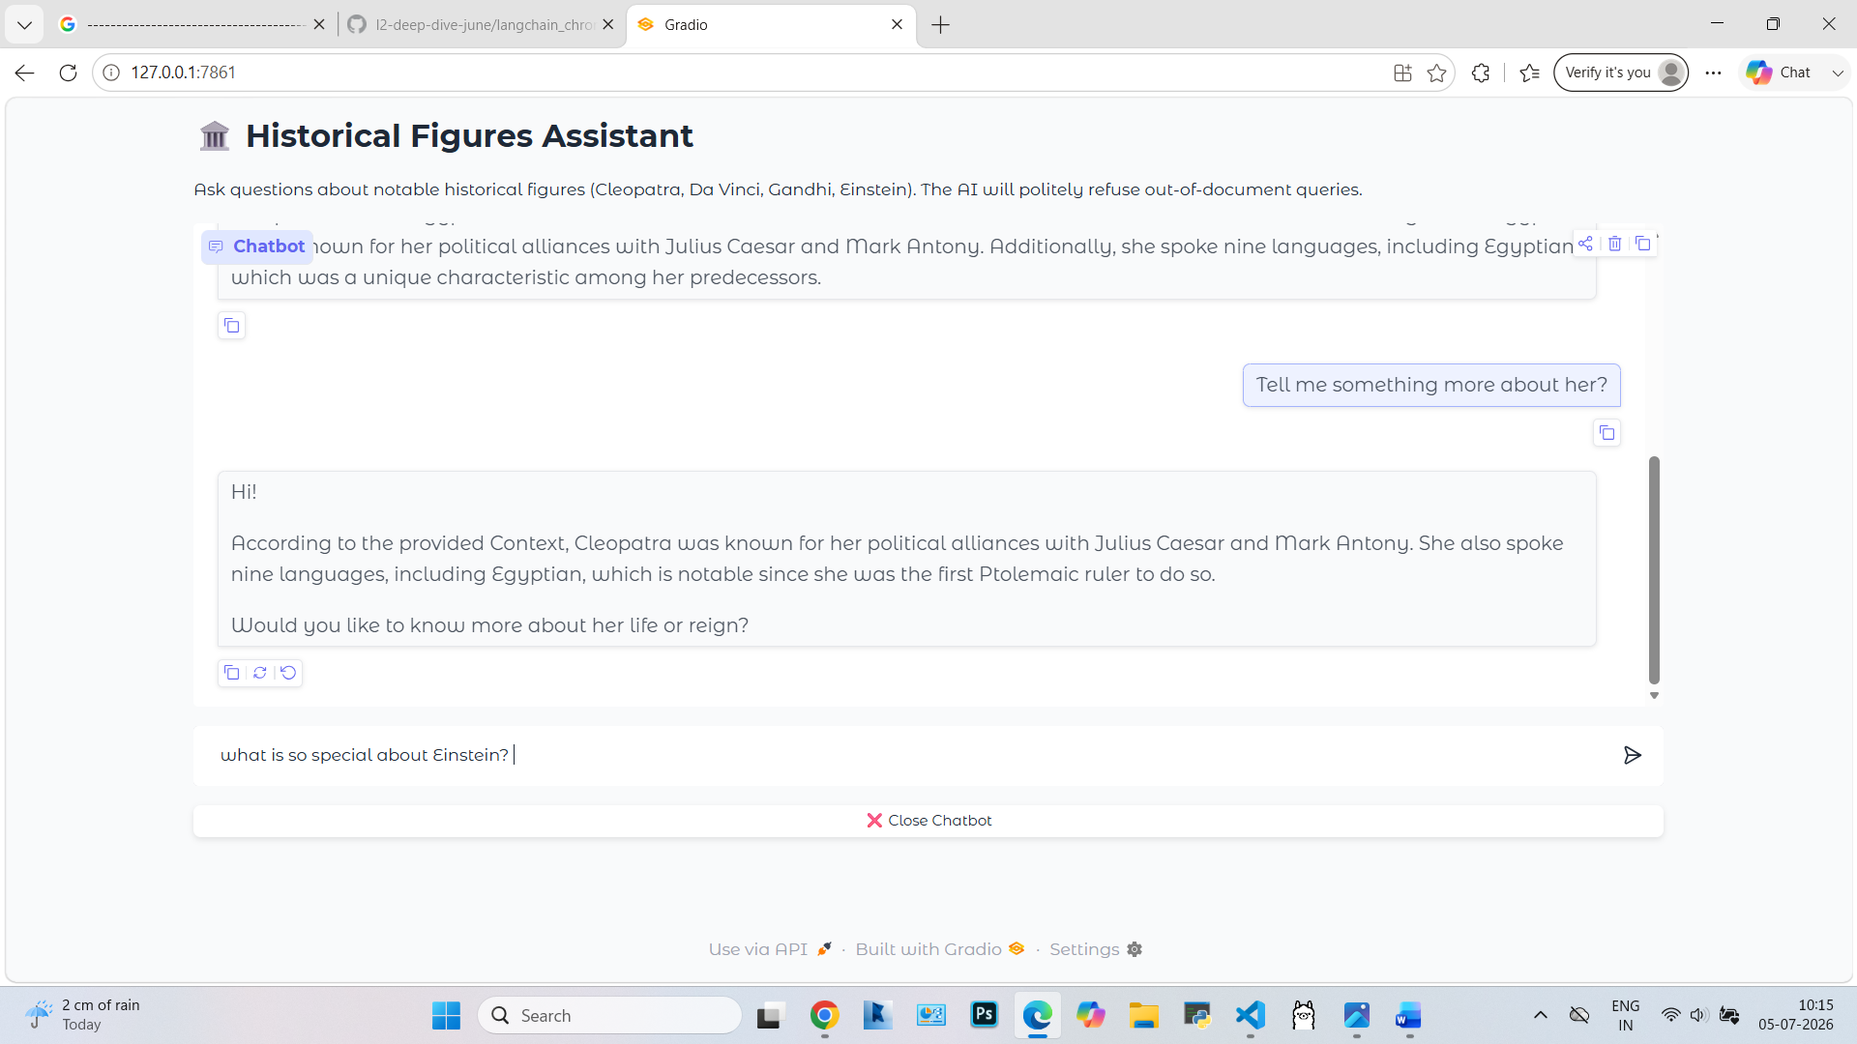
Response
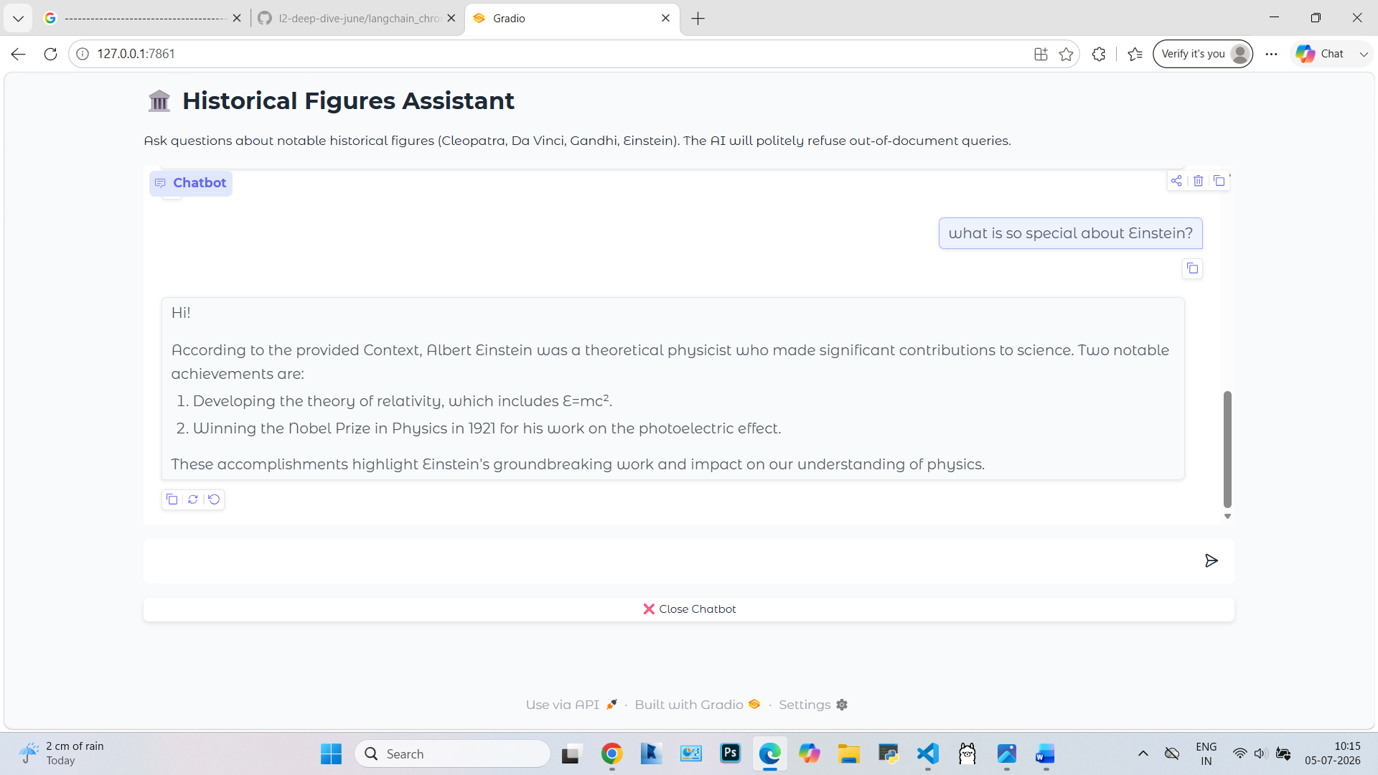

User : What all historical personality knowledge you have?
Response
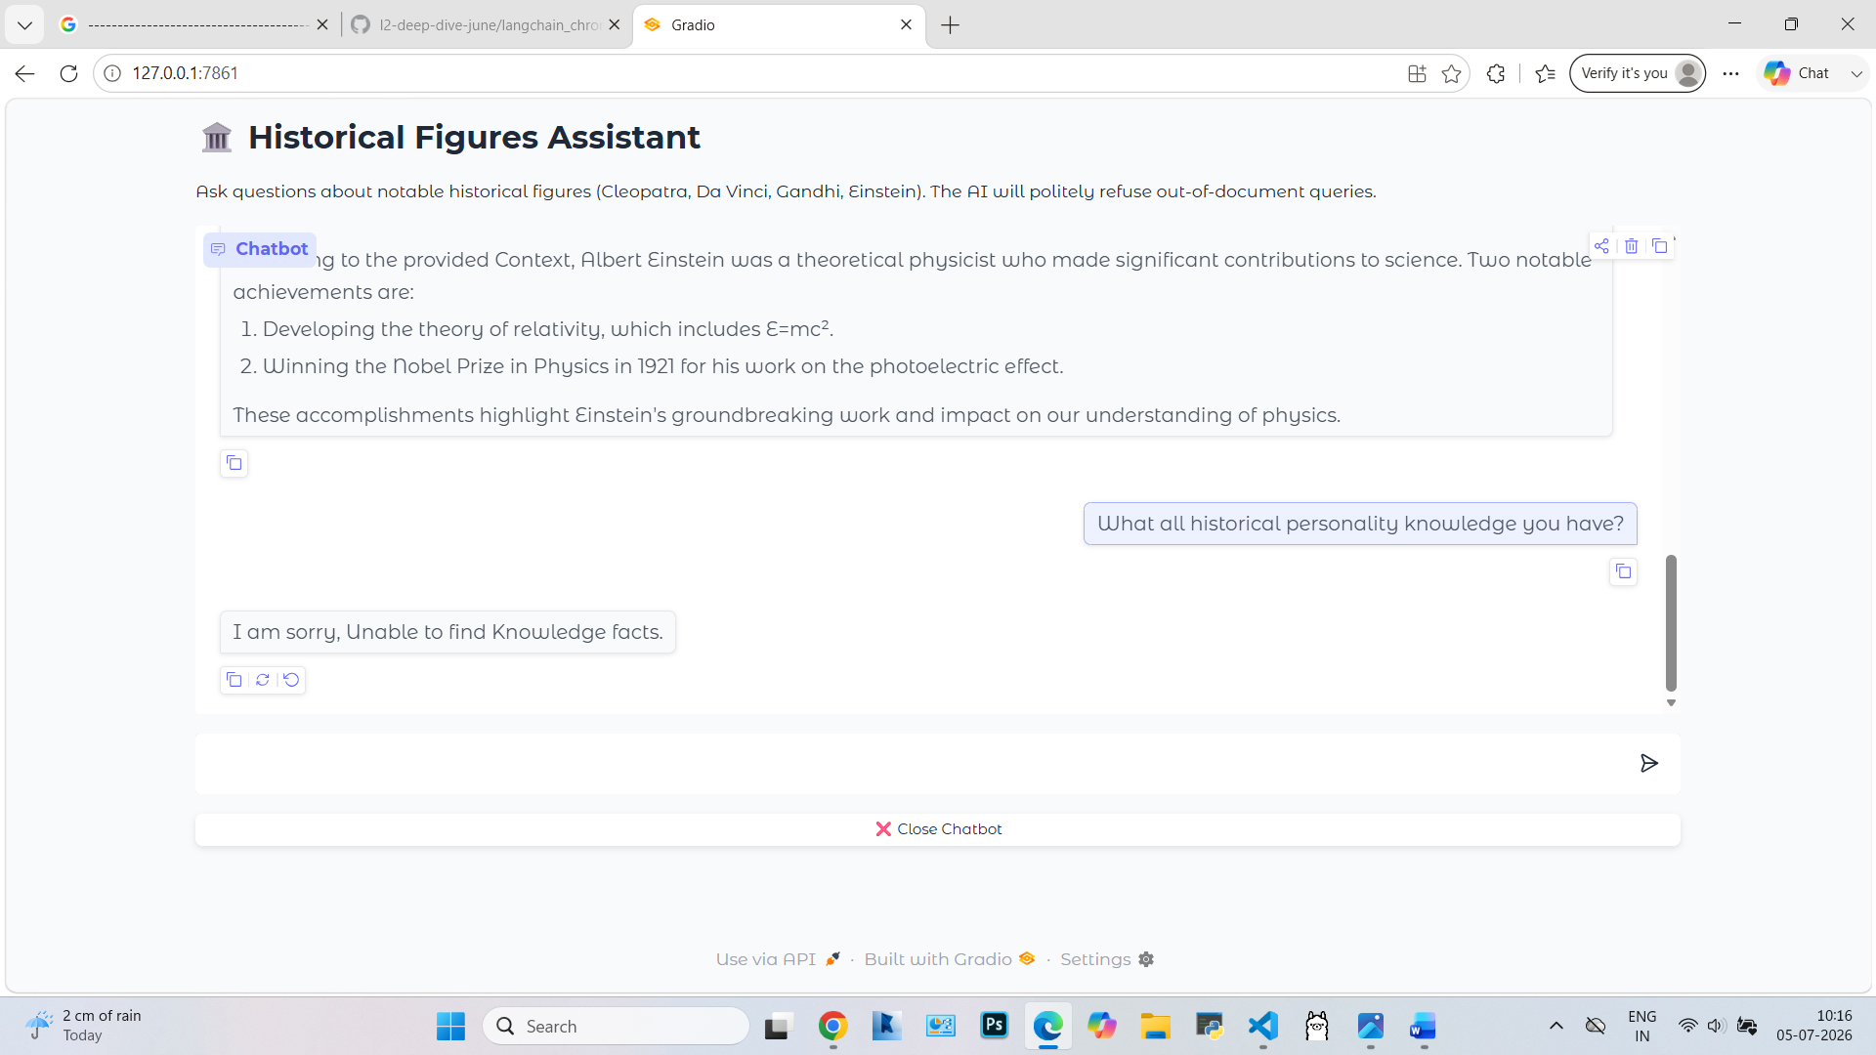

User : who is Dnesh Kakde?
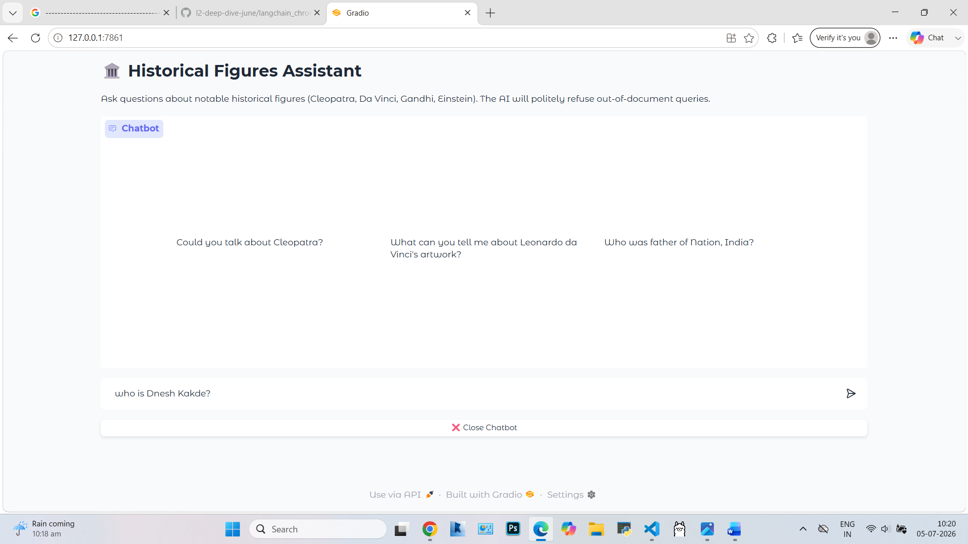
Response
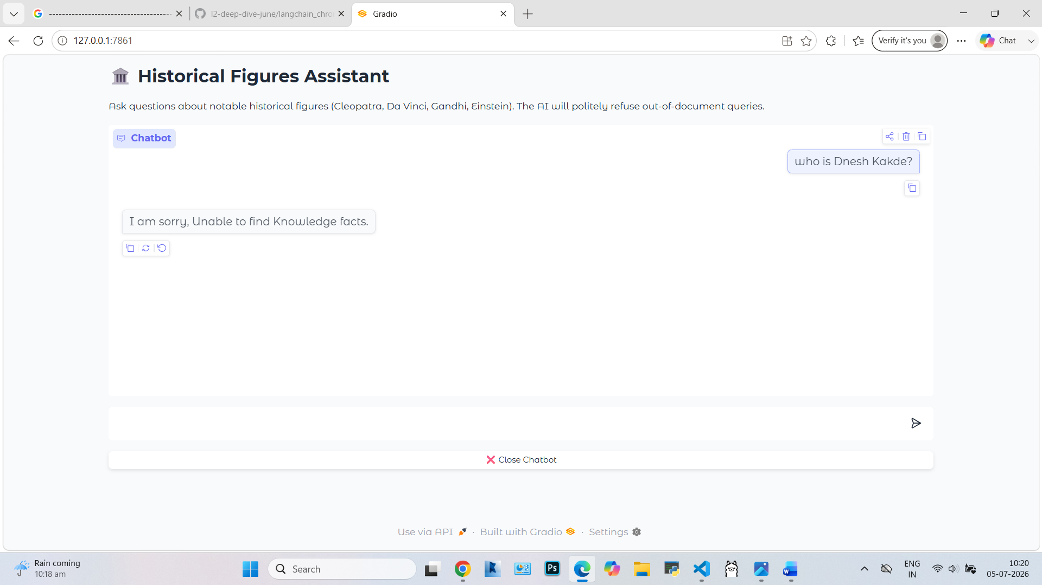

User : Thank You,Bye
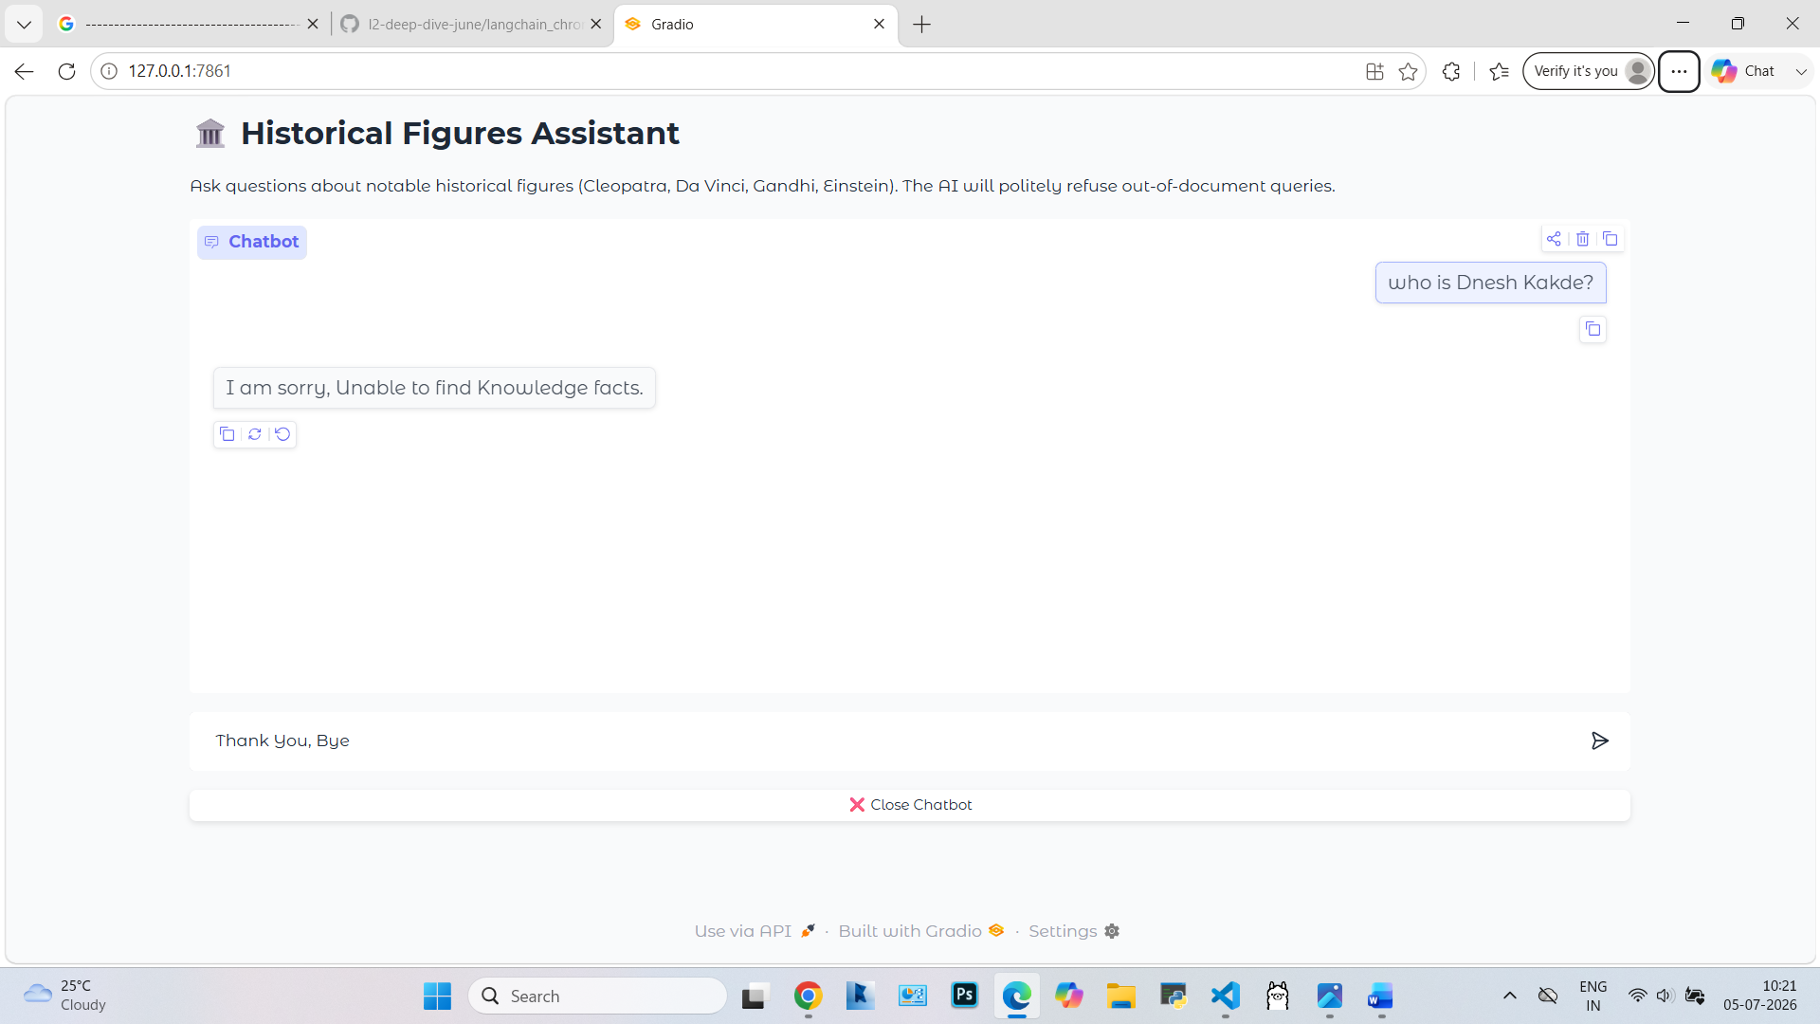
Response
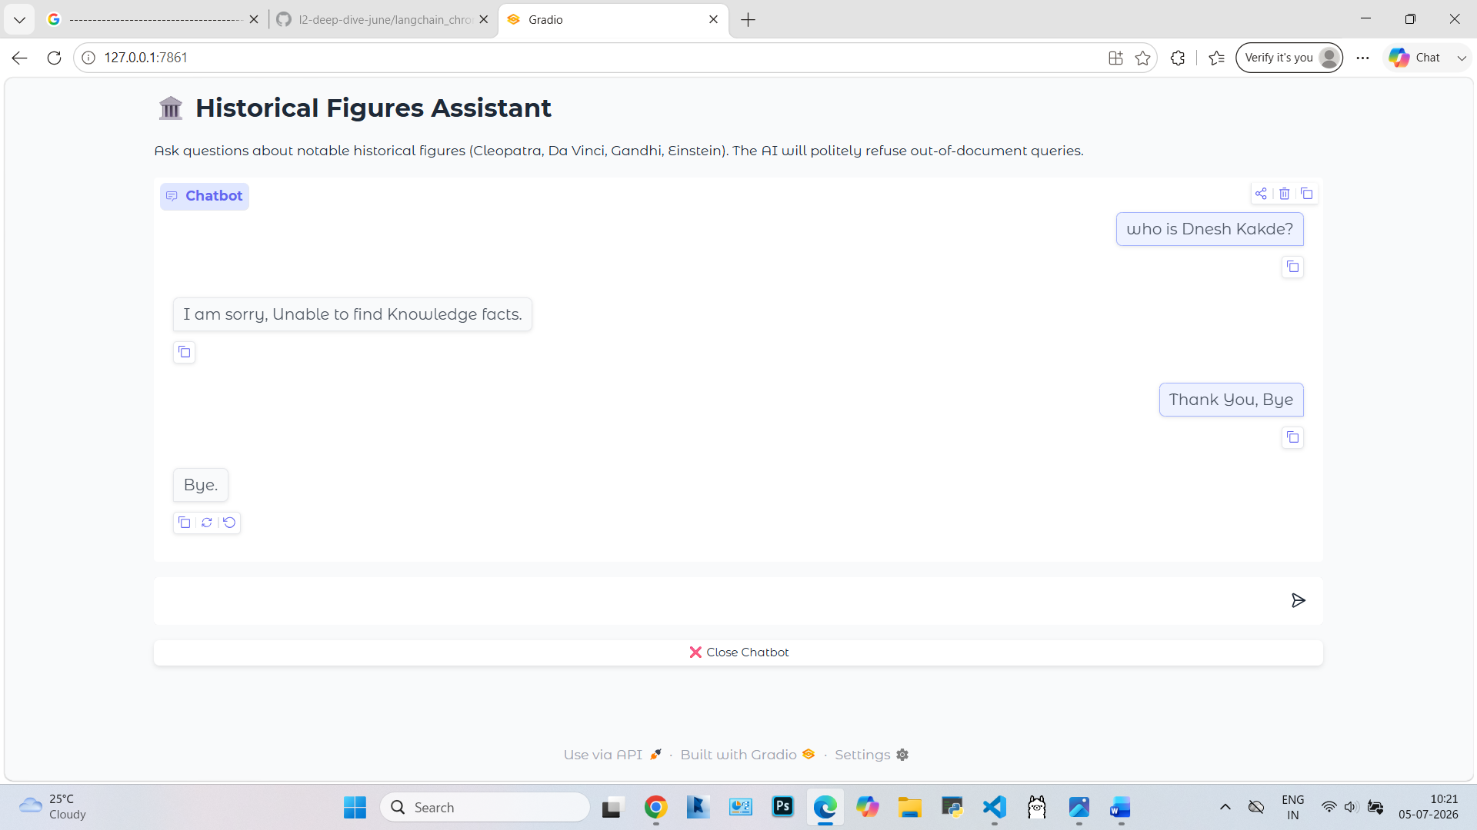

User : Want to close and clicks on close button provided
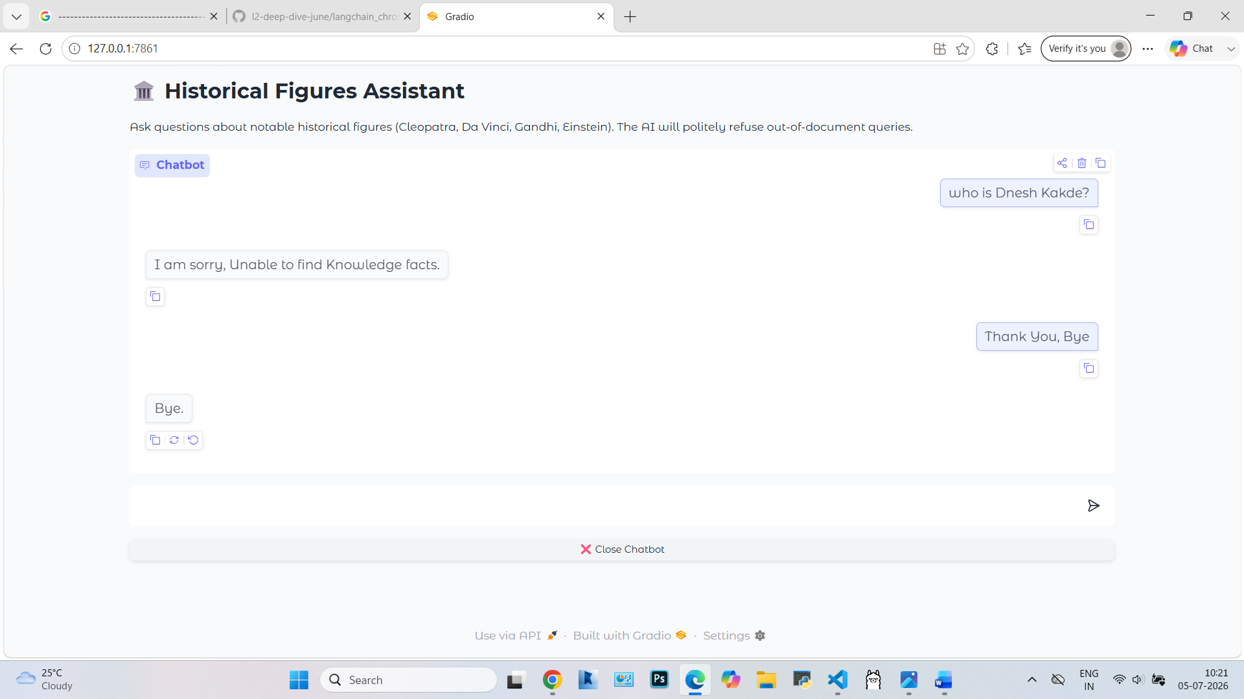
Response
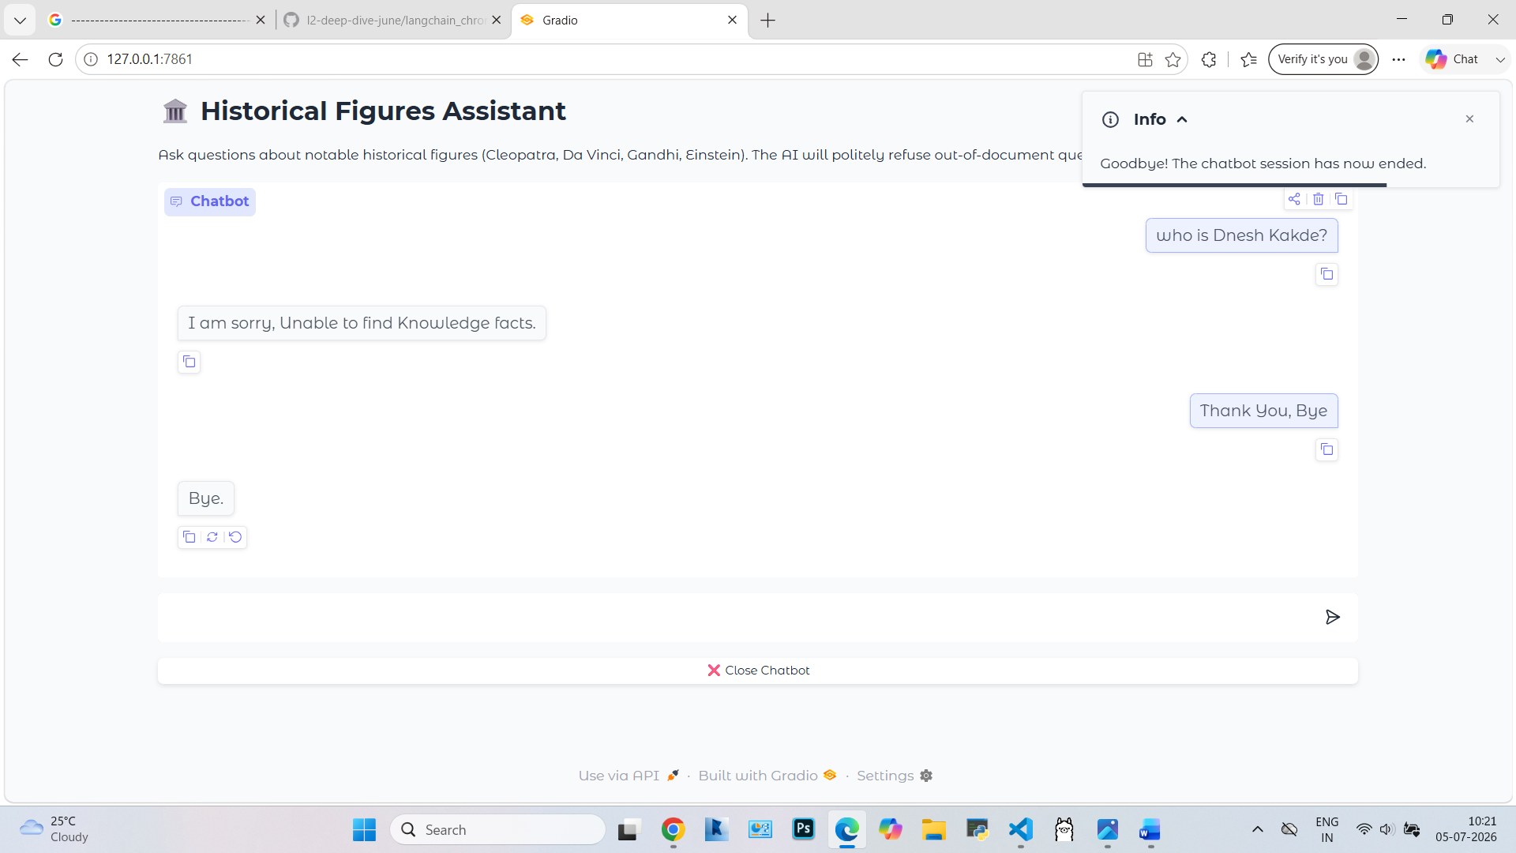

Code Explanation:
STEP 1: Imported all Dependencies required for this chatbot. Imported specific dependencies required for document loading, retrieving and chat prompt, Embeddings dependencies.
import gradio as gr
import langchain
import langchain_core
import langchain_ollama
import langchain_chroma
import langchain_classic
from langchain_core.documents import Document
from langchain_core.prompts import PromptTemplate
from langchain_chroma import Chroma
from langchain_ollama import OllamaEmbeddings, ChatOllama
From langchain_classic.chains.combine_documents
import create_stuff_documents_chain
from langchain_classic.chains import create_retrieval_chain

STEP 2: Different Document knowledge addition, preparation, creation of documents and providing metadata and creating vector store setup.
# --- 1. DATA PREPARATION & VECTOR STORE SETUP ---
doc1 = Document(
page_content="Cleopatra (69 BCE - 30 BCE). Nationality: Egyptian. Lifespan: 69 BCE - 30 BCE. Contribution: Last active ruler of the Ptolemaic Kingdom of Egypt. Trivia: Known for her political alliances with Julius Caesar and Mark Antony. Spoke nine languages, including Egyptian, unlike her predecessors.",
metadata={"person": "Cleopatra"}
)
doc2 = Document(
page_content="Leonardo da Vinci (1452 - 1519). Nationality: Italian. Lifespan: 1452 - 1519. Contribution: Polymath, artist, and inventor. Trivia: Painted the Mona Lisa and The Last Supper. His notebooks contain designs for flying machines and anatomical studies far ahead of his time.",
metadata={"person": "Leonardo da Vinci"}
)
doc3 = Document(
page_content="Mahatma Gandhi (1869 - 1948). Nationality: Indian. Lifespan: 1869 - 1948. Contribution: Leader of India's non-violent independence movement. Trivia: Pioneered satyagraha, a form of non-violent resistance. Led the Salt March in 1930 to protest British salt taxes.",
metadata={"person": "Mahatma Gandhi"}
)
doc4 = Document(
page_content="Albert Einstein (1879 - 1955). Nationality: German (later Swiss, American). Lifespan: 1879 - 1955. Contribution: Theoretical physicist. Trivia: Developed the theory of relativity, including E=mc². Won the Nobel Prize in Physics in 1921 for his work on the photoelectric effect.",
metadata={"person": "Albert Einstein"}
)

Combining all documents by providing their list to DOCS

docs = [doc1, doc2, doc3, doc4]
STEP 3: Initializing Vector Database using local granite-embeddings model folder name is my_chroma_db with this collection name is my_collection. The K=2 instruct LLM to retrieve top most matching two documents related to user query.

# Initialize Vector DB (uses locally stored 30m embedding model)
vector_store = Chroma(
embedding_function=OllamaEmbeddings(model="granite-embedding:30m"),
persist_directory="my_chroma_db",
collection_name="my_collection",
)
vector_store.add_documents(docs)
retriever = vector_store.as_retriever(search_kwargs={"k": 2})

STEP 4: chatollama mediate between code and LLM to generate text as per user query and make it most acurate in language format. Temperature 0 is used to be more deterministic while answering.

# --- 2. MODEL & RETRIEVAL CHAIN PIPELINE ---
llm = ChatOllama(model="llama3.2:latest", temperature=0.0)

STEP 5: Below step sets a guidelines for response from LLM like polite and provide details of when user greets and exists how the response should be.

# The template strictness forces a polite out-of-bounds disclaimer
prompt_template = """
You are an expert history information assistant. Your goal is to answer questions using ONLY the provided context below.

Context:
{context}

Instructions:
1. Carefully analyze the provided Context to see if it mentions the historical figure or information requested.
2. If the Context contains the answer, summarize or explain it accurately based on that text.
3. If context contain greetings like 'Hi','Hello' responce with greeting like Hi.
4. If context is Thank You, Bye so say same thing back to user.
5. If asked about you like "How are you" say "Im good, Thank you".
6. If the Context does NOT contain information to answer the question, or if the question is completely out-of-scope (unrelated to the individuals mentioned in the context), reply EXACTLY with:
"I am sorry, Unable to find Knowledge facts."

Question: {input}
Answer:
"""

STEP 6: This below code links a documents and then combines with document database to create a final, unified stream of test for creating response.
prompt = PromptTemplate.from_template(prompt_template)

document_chain = create_stuff_documents_chain(llm, prompt)
qa_chain = create_retrieval_chain(retriever, document_chain)

STEP 7: Below code defines a function that transmits user input to an LLM and retrieves a response with provinde gradio chatbot user friendly interface act like chatbot and links a document database for generating responses also provide close button for a proper shutdown of chatbot with a "Goodbye" notification.
# --- 3. GRADIO INTERFACE CONFIGURATION ---
def chat_bot_response(message, history):
"""
Function targeting incoming messages from Gradio UI, pushing queries
through LangChain pipeline, and returning the structured string answer.
"""
try:
response = qa_chain.invoke({"input": message})
return response["answer"]
except Exception as e:
return f"An internal connection error occurred: {str(e)}"

def print_goodbye_message():
"""
Step 1: Broadcasts visual browser updates and console prints
while the web server infrastructure is fully alive.
"""
print("\nGoodbye! The chatbot session has ended safely.")
gr.Info("Goodbye! The chatbot session has now ended.")
# You must return something or None to allow the event chain to continue
return None

def kill_server_instance():
"""
Step 2: Shuts down the active networking block after messages execute.
"""
print("Shutting down Gradio application...")
demo.close()

# Build the layout window framework
with gr.Blocks(theme="soft") as demo:
gr.Markdown("# 🏛️ Historical Figures Assistant")
gr.Markdown("Ask questions about notable historical figures (Cleopatra, Da Vinci, Gandhi, Einstein). The AI will politely refuse out-of-document queries.")

# Primary Chat Engine Window
chat_ui = gr.ChatInterface(
fn=chat_bot_response,
examples=[
"Could you talk about Cleopatra?",
"What can you tell me about Leonardo da Vinci's artwork?",
"Who was father of Nation, India?"
]
)

# ADD ONLY THIS ONE LINE RIGHT BELOW IT:
chat_ui.textbox.submit(fn=None, js="() => { document.querySelector('textarea, input[type=text]').focus(); }")

#Action Shutdown Button Row
with gr.Row():
close_btn = gr.Button("❌ Close Chatbot", variant="stop", size="sm")

# 2. FIX: Chain the actions sequentially so messages trigger BEFORE close()
close_btn.click(fn=print_goodbye_message, inputs=None, outputs=None).then(
fn=kill_server_instance, inputs=None, outputs=None
)

if __name__ == "__main__":
# Launches inside your browser only
demo.launch(inline=False)

